|  |  |  |
| --- | --- | --- |
| Hamming distance | # of detectable errors | # of correctable errors |
| 8 | Up to 7 bits | Up to 3 bits |
| 16 | 15 | 7 |
| 1000 | 999 | 499 |
| 41 | 40 | 20 (less than 20.5) |
| 17 | 16 | 8 |
| h | < h | < h/2 |

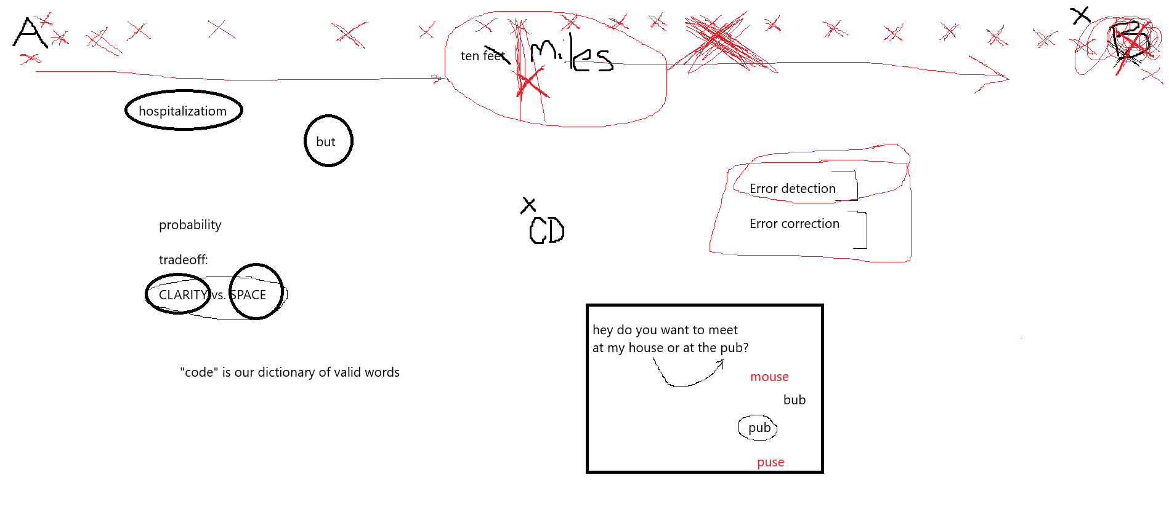

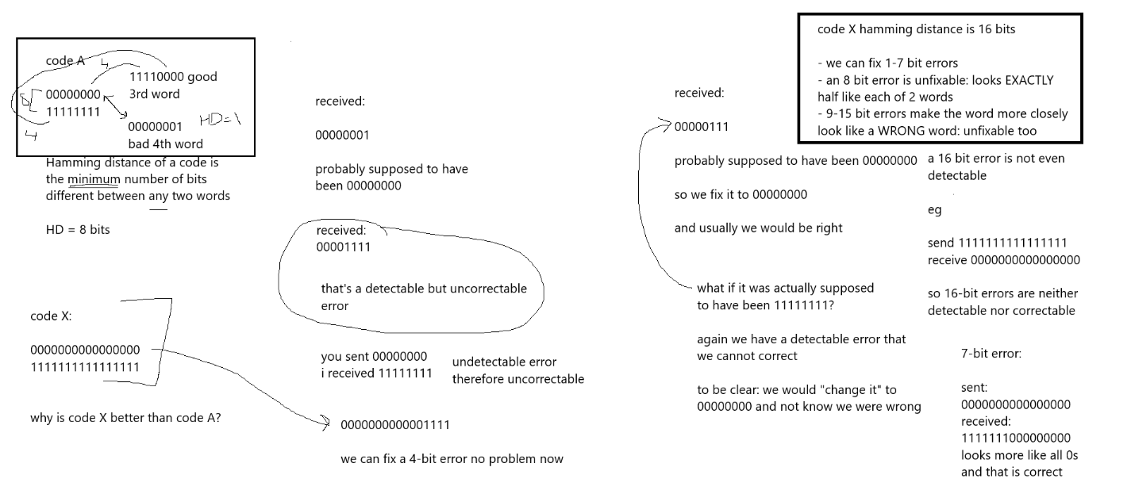

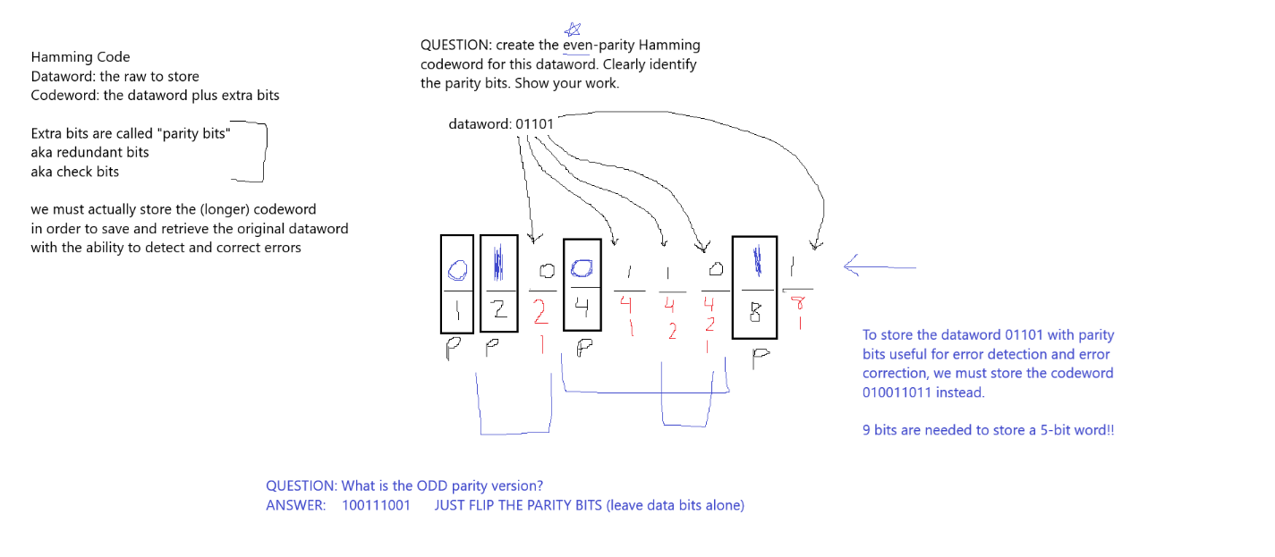

Create the even-parity Hamming codeword for these datawords:   
a) 0   
b) 111   
c) 01110001101001

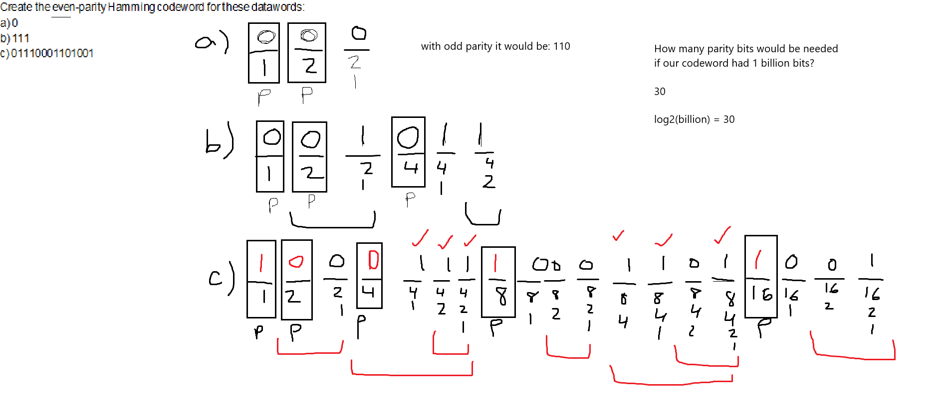

The following Hamming codewords were made using even parity.

1. Are there errors?
2. Where? How do you know?
3. What was the original dataword supposed to have been?

#1: 101101111

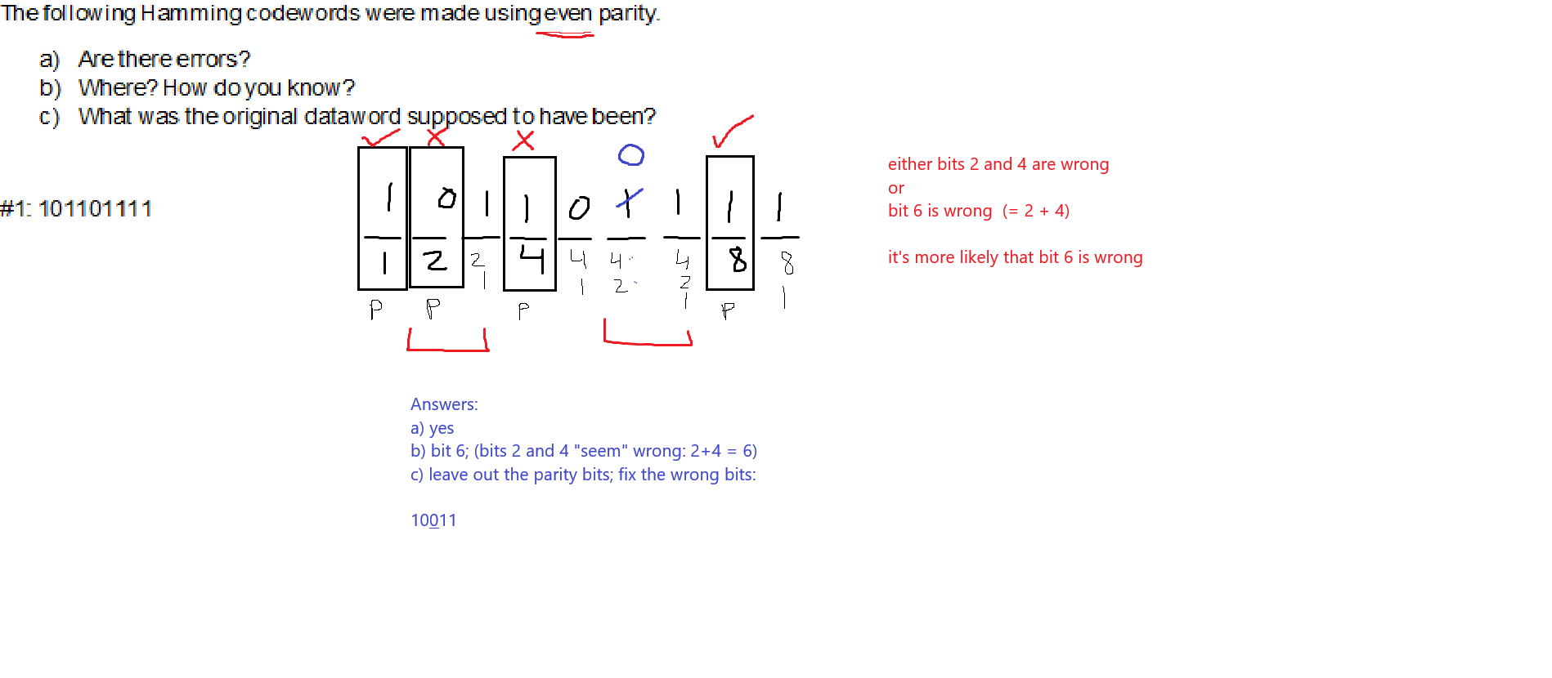

SAME QUESTION but the codeword was made using ODD parity.

ANSWER: bit 9 (= 1+8); the original dataword would have been: 10110

The following Hamming codewords were made using even parity.

1. Are there errors?
2. Where? How do you know?
3. What was the original dataword supposed to have been?

011000011011

